Lab 1: Requirements Engineering & UML Use-Case Modelling
Problem Statement #24 — Public Bus Live Tracking & Crowding Estimator
Domain: Smart Cities, Transport & Logistics
Name: VAINIK
SRN: PES1UG24CS513
PES University — Dept. of CSE

1. Problem Context & Overview
The system is a municipal transit intelligence platform that ingests GPS feeds from city buses, estimates arrival times (ETA) at downstream stops, and computes passenger crowding levels from ticketing sensors.
Target Stakeholders / Actors: Commuter, Fleet Controller

2. Functional Requirements (FR-001 to FR-005)
ID | Type | Description | Priority | Acceptance Criteria | Rationale
FR-001 | Functional | The system shall ingest GPS coordinates from all active buses every 5 seconds and recalculate arrival ETAs for all upcoming stops on the route based on current speed and traffic conditions. | High | Pass: ETA decreases monotonically as the bus approaches a stop under normal traffic. Fail: ETA increases while the bus is approaching the stop. | Accurate, real-time ETAs let commuters plan journeys and minimize wait time.
FR-002 | Functional | The system shall compute a passenger crowding level (Low / Medium / High) for each bus in real time using ticketing (tap-in/tap-out) sensor counts. | High | Pass: crowding level updates within 10 seconds of a tap event and matches the expected occupancy band. Fail: crowding level stays static despite boarding/alighting. | Lets commuters make informed boarding decisions and helps balance loads across the fleet.
FR-003 | Functional | The system shall allow a commuter to search for a bus route or stop by name/number and view the live location of all buses currently serving that route on a map. | Medium | Pass: search returns matching routes/stops within 2 seconds and displays live bus markers. Fail: no results for a valid route/stop, or markers do not reflect current position. | Route/stop search is the primary entry point for commuters to access tracking information.
FR-004 | Functional | The system shall send push notifications to subscribed commuters when a tracked bus is delayed beyond a configurable threshold, or when crowding on that bus reaches High. | Medium | Pass: notification delivered within 30 seconds of threshold breach. Fail: no notification sent despite breach, or duplicate/spam notifications for the same event. | Proactive alerts reduce uncertainty and let commuters adjust plans in advance.
FR-005 | Functional | The system shall provide a Fleet Controller dashboard to monitor all active buses, and allow the controller to reroute a bus or update its schedule in real time. | High | Pass: rerouted/updated schedule reflects on the dashboard and propagates to commuter-facing ETAs within 15 seconds. Fail: dashboard shows stale data, or changes do not propagate. | Fleet controllers need real-time control to respond to breakdowns, traffic, or demand surges.

3. Non-Functional Requirements (NFR-001 & NFR-002)
ID | Type | Description | Priority | Acceptance Criteria | Rationale
NFR-001 | Performance & Security | The tracking engine shall handle telemetry streams from up to 1,000 active transit vehicles simultaneously, with end-to-end encrypted (TLS) data transmission. | High | Pass: benchmarking confirms target latency (<2s ingestion-to-update) and security standards under a simulated peak load of 1,000 vehicles. Fail: latency exceeds threshold or unencrypted data is detected. | City-wide fleet scale and the public-safety-adjacent nature of transit data demand both scale and security guarantees.
NFR-002 | Availability & Reliability | The platform shall maintain 99.5% uptime during service hours (5 AM - 12 AM) and gracefully degrade to last-known-position display if GPS/ticketing feeds are temporarily unavailable. | High | Pass: monitored uptime over a 30-day period meets or exceeds 99.5%, and the UI clearly labels stale data during outages. Fail: downtime exceeds threshold or the app shows blank/crashed data during an outage. | Commuters depend on the app throughout the day; downtime during commute hours undermines trust in the transit system.

4. UML Use-Case Diagram
Actors: Commuter, Fleet Controller. The diagram below models all primary use cases for both actors, plus one <<include>> relationship (both "View Live Bus Location" and "Monitor Fleet Dashboard" include "Authenticate User") and one <<extend>> relationship ("Report Issue" optionally extends "View Crowding Level", triggered only when a commuter flags the displayed crowding data as inaccurate).
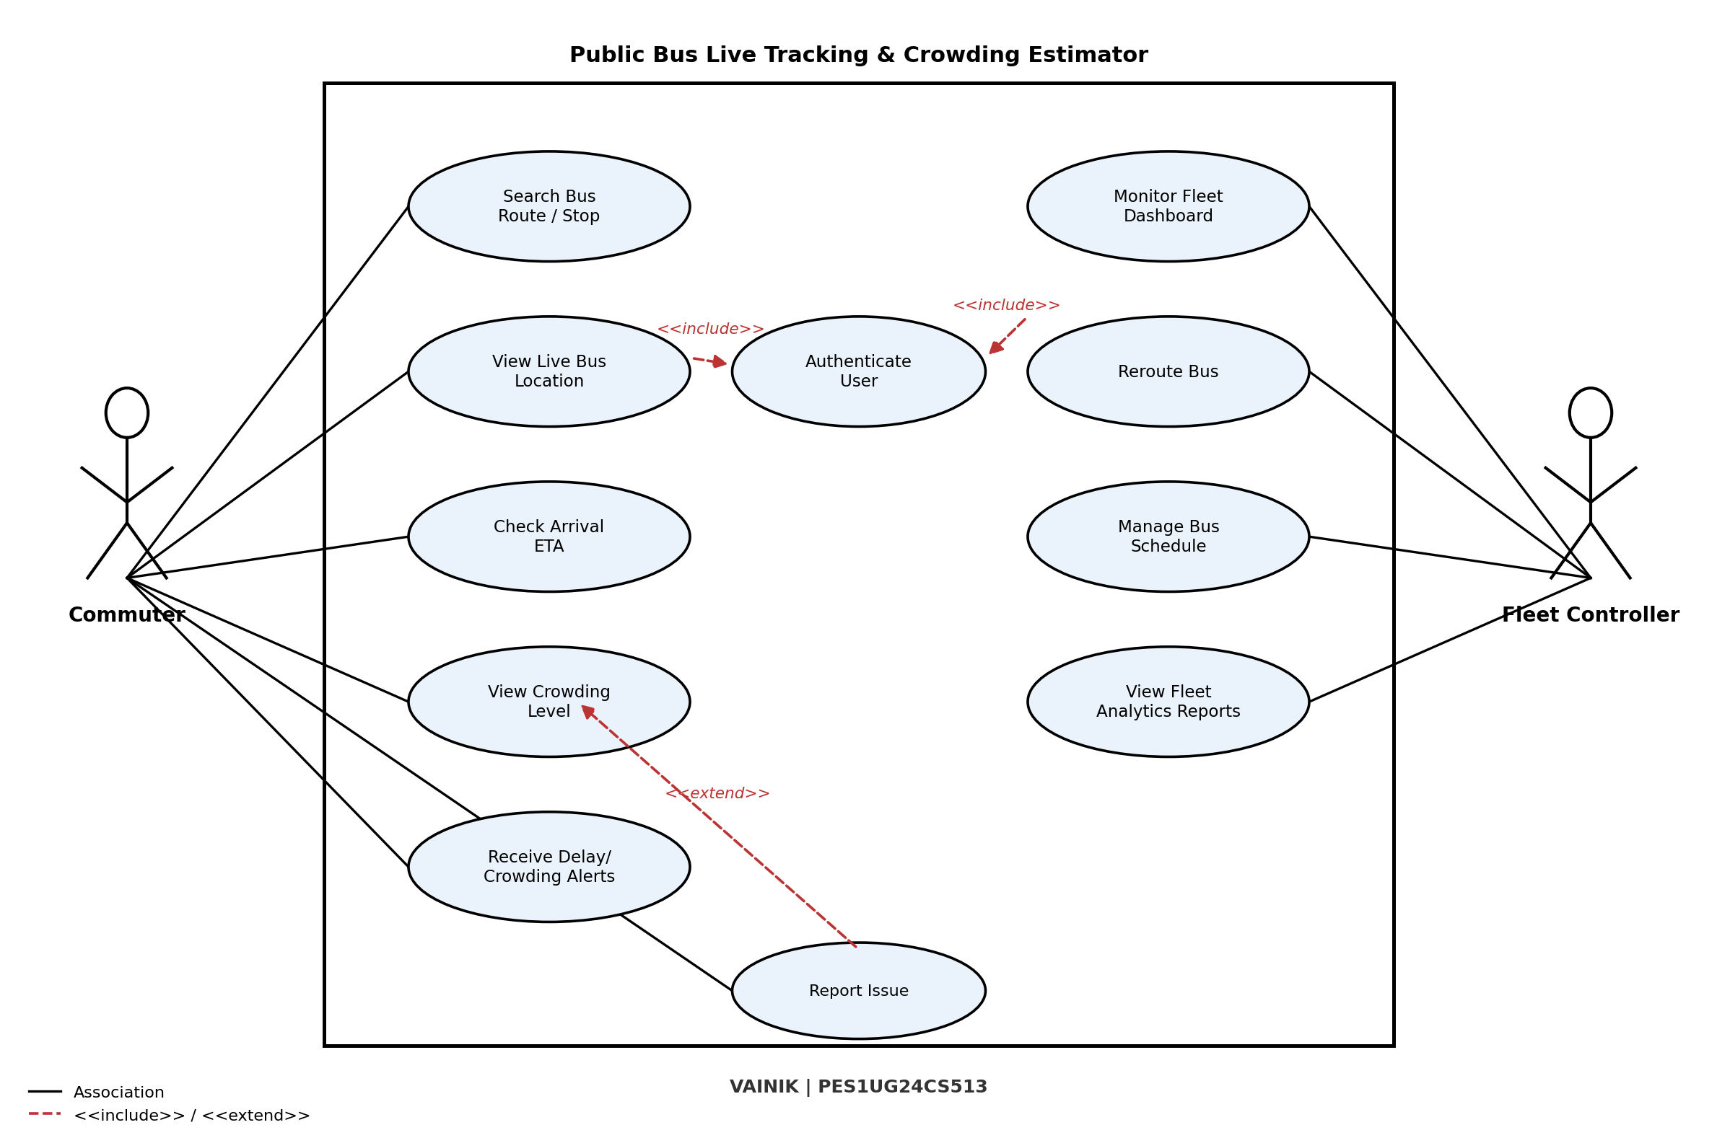

5. Use-Case Flow Specification

Use Case: View Live Bus Location and ETA
Primary Actor: Commuter

Preconditions
- The commuter has the mobile app installed and an active internet connection.
- The commuter has successfully completed the "Authenticate User" use case (or is permitted guest access, per system policy).
- At least one bus is actively transmitting GPS telemetry for the selected route.

Postconditions
- Success: the commuter sees the selected bus's current location on a live map, along with an updated ETA and crowding level for their chosen stop.
- Failure: the commuter is shown a "position unavailable" state along with the last known data, and no live update is rendered.

Main Success Scenario
- 1. The commuter opens the app and searches for a bus route or stop.
- 2. The system includes "Authenticate User" to validate the commuter's session if not already authenticated.
- 3. The system retrieves the list of buses currently active on the requested route.
- 4. The commuter selects a specific bus from the list.
- 5. The system fetches the most recent GPS coordinate (received within the last 5 seconds) for the selected bus.
- 6. The system calculates the ETA to the commuter's chosen stop using current speed, distance, and live traffic data.
- 7. The system renders the bus's live position on the map and displays the ETA and crowding level.
- 8. The system refreshes the bus position and ETA every 5 seconds until the commuter closes the tracking screen.

Alternate Flow: GPS Signal Loss (branches at Step 5)
- 5a. The system detects that no new GPS coordinate has been received from the bus for more than 30 seconds.
- 5b. The system flags the bus as "Signal Lost" and displays its last known position with a timestamp instead of a live marker.
- 5c. The system recalculates ETA using the last known speed/position and labels it "Estimated (Stale)".
- 5d. Once a new GPS coordinate is received, the system resumes the Main Success Scenario at Step 5.

